Proceedings of the ASME 2024
International Design Engineering Technical Conferences and
Computers and Information in Engineering Conference
IDETC/CIE2024
August 25-28, 2024, Washington, DC, USA

DETC2024-142746

Adaptive Navigation of Multirobot Systems in 2D Vector Fields

Christopher Waight², Christopher Kitts¹
¹Santa Clara University, Santa Clara, CA, USA
²Santa Clara University, Santa Clara, CA, USA

Abstract
Adaptive Navigation of a multi-robot system maneuvers the system of robots based solely on distributed sensor readings of the environment. This approach allows for the exploration of unknown environments and stochastic environments with moving features of interest. Research in this area primarily involves work done in environments modelled as scalar fields, with initial work finding extrema in environments modelled as vector fields. This document describes how vector fields can be constructed from simpler basis vector fields using superposition and it also identifies regions of interest within these environments including local extrema points, stagnation points, equi-magnitude contours, and separatrix trajectories. Each of these regions of interest are demonstrated using the superposition technique described above. It recaps cluster control formulation, a centralized method of formation control for multirobot systems which is used in this research. A few control primitives which rely on purely reactive control are developed to maneuver the multi-robot system to features of interest in vector fields. These control primitives are then demonstrated in several simulated environments. The performance of each control primitive is then discussed, and visualizations of their performance is included, followed by a brief explanation of upcoming plans to demonstrate these primitives on a physical test bed.
Keywords – Control, Mechatronics and Electro-Mechanical Systems, Mobile Robots, Robotic Systems.

Introduction
Multirobot systems are coordinated groups of robots that often have capabilities beyond that of individual robots [1][2]. In a multirobot system, each robot offers speed, precision, repeatability, safety, and resilience to extreme environments [3]. When grouped into a multirobot system, the system has additional advantages such as redundancy, expanded coverage, and collaborative task execution, which is vital for missions ranging from search and rescue to environmental monitoring [4-5].
When the environment is known or mapped, path planning can be effectively executed using predefined navigation methods. In instances where environmental knowledge is limited, Adaptive Navigation methods update a vehicle’s desired trajectory in real time using environmental readings as inputs [28]. These methods retain the benefits of being able to withstand harsh conditions, but further enabling robots to navigate in environments dynamic or communication-restricted environment [6]. Multirobot Adaptive navigation in scalar field environments is well studied in both simulation and practice. This includes formation control using centralized and decentralized architectures, and developing control strategies for extremum seeking, contour following, and other regions of interest [7-11]. Use cases for this include tracking contamination areas, oil spills and source points [12-15], and plume front tracking [16].
Extending these methods to vector field environments is in its infancy, with most of the work done is using artificial vector fields for formation control [17-19]. There are only a few using distributed vector readings from a multirobot system in a vector field [20-23]. It has been shown in simulation that control primitives for multirobot systems exist, including methods for navigating to the fastest flowing point in a stream, navigating to the center of a vortex, sink or source, as well to the center of a sinking vortex [13]. Indoor test beds have also been developed to demonstrate a few of these primitives [22]. This extension to vector fields provides multirobot systems with new methods to navigate extreme environments in fluid flow fields such as rivers, oceans, and aerial spaces [21-24]. Moreover, this extension allows for adaptive navigation methods to be used in extraterrestrial settings autonomous navigation through non-uniform gravitational fields, magnetic fields, and thermal gradients, and other vector fields, such as during asteroid mining [25] [26].
In this paper, we extend research in vector field adaptive navigation using multirobot systems with centralized control to locating additional features of interest using newly developed control primitives. Section 2 covers the high-level control architecture of the multi-robot system. In Section 3, the paper discusses different basis for creating vector fields using superposition and introduces a list of features of interest. Section 4 defines control primitives used to navigate to each feature of interest in a purely reactive manner. Section 5 discusses the performance and limitations of these control primitives in simulated environments. Section 6 closes this work with a few ideas for future research. Section 7 acknowledges all who made this research possible.

MATERIALS AND METHODS

2.1 Adaptive Navigation Control Architecture
The controller architecture used for navigation of the multirobot system can be divided into 3 main parts: a layer with individual robot controllers for control over each robot, a layer with a cluster space controller for formation control, and an adaptive navigation layer for executing the control primitives. An overview of this architecture can be seen in figure 1 [14].
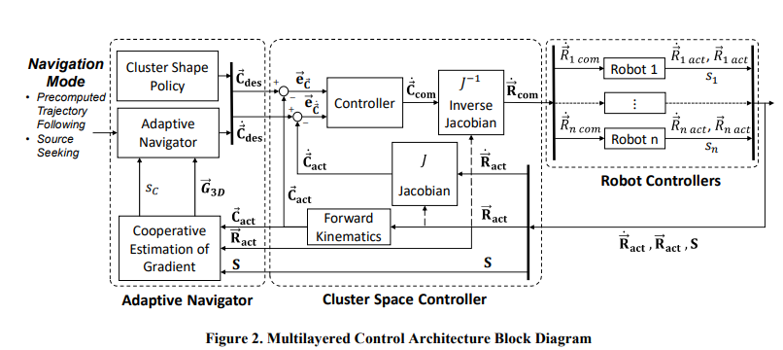
FIGURE 1: MULTILAYERED CONTROL ARCHITECTURE BLOCK DIAGRAM
The robots used are abstracted to a single massless point in space, and the robots are assumed to be omnidirectional in simulation. Each robot has sensors that return a single instantaneous vector reading of the environment, as well as its relative location to all the other robots.
To maintain formation, a cluster space controller is used. Cluster Space control is a technique developed by Dr. Chris Kitts of Santa Clara University. In this technique, all robot positions are described geometrically relative to a cluster frame. A generalized cluster in a 2-dimensional plane can be seen in figure 2 [14].
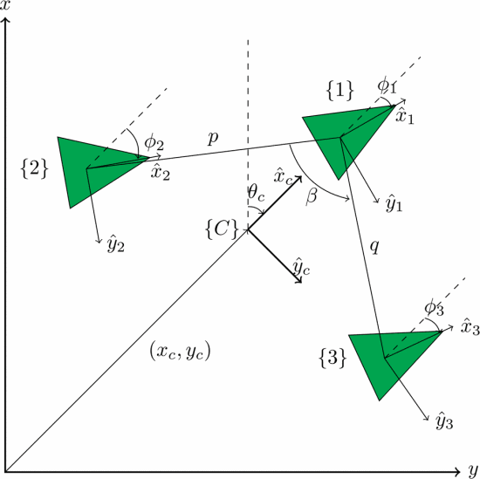
FIGURE 2: A 3-ROBOT CLUSTER WITH CLUSTER FORMATION VARIABLES
For this research, a 3 robot cluster with the formulation used in figure 2 was used. The cluster values, p=0.854, q = 0.854, and β= 0.359 were chosen as values for the cluster variables. The robot orientation pose variables are not used in this study, as the robots are assumed to be omnidirectional.
The adaptive navigation layer hosts the control primitives and the cluster shape policy. It tells the cluster space layer which shape policy to use and commands the entire cluster in a direction according to control primitive.
This architecture has been successfully demonstrated in a variety of studies, including finding local extrema and contour following in scalar fields, and in an initial study that finds extrema points in vector fields. It has also been used to maneuver two balloons in a 3D environment.

2.2 Construction of Complex Vector Fields
The Laplace Equation, given by:
$$\begin{aligned}∇^{2} ϕ=0 \#\left(1\right)\end{aligned}$$
Where $∇^{2}$ is the Laplace operator and $ϕ$ is a scalar potential function. The gradient of the potential functions can be described as vectors. Furthermore, the inherent linearity property of the solutions allows for superposition of solutions. This motivates the idea that solutions to the Laplace equation can be effectively superimposed to model complex vector fields. This methodology was pivotal in creating model environments for our simulations.
Potential functions that satisfy the Laplace equation include uniform flows, sinks, sources, dipoles, and vortices, under the assumption of ideal conditions.
Uniform flows are the simplest solution, representing a constant velocity in a given direction. This field could be superimposed with other uniform flows over a smaller region to create non-uniform flows, such as an increased current in the middle of a river flowing faster (see Fig 3).
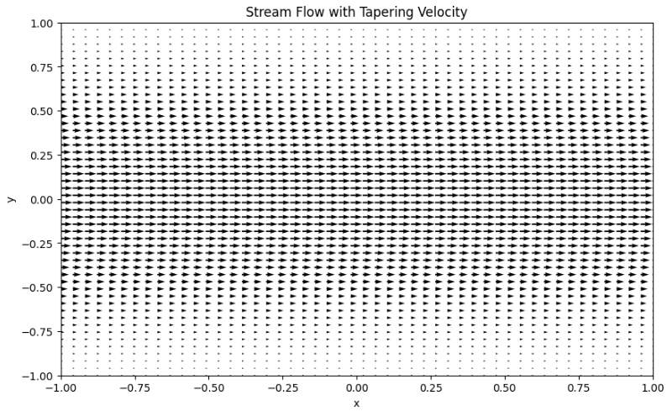
FIGURE 3: MODELLING A RIVER WITH A STRONG CENTRE FLOW AS SUPERIMPOSED UNIFORM FLOWS
Sinks and sources have potential functions that get stronger near the point of origin. This can represent points where fluids enter or exit the flow field, or the source of a gravitational point mass or magnetic pole, modelled with a magnitude of r⁻² and pointing in a direction away from or towards the extrema point for sources and sinks respectively (see Fig 4). Examples of these in nature include hot springs, celestial bodies, and planetary magnetic poles.
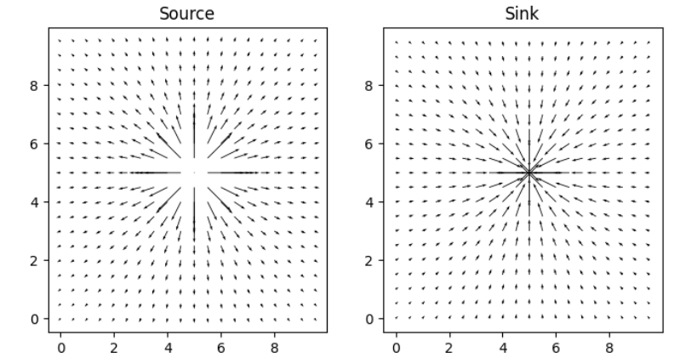
FIGURE 4: A SOURCE POTENTIAL VECTOR FIELD
Vortices (free and fixed) are also valid potential fields that satisfy the Laplace equation. These can be used to model whirlpools and atmospheric pressure systems, or the wake of an object in a uniform flow.
Magnetic dipoles can also be modeled as a fundamental solution to the Laplace equation. Alternatively, dipoles can be modeled as a source point that is located infinitesimally close to a sink point (see Fig 5). In this figure, the vector sizes are normalized for better visualization.

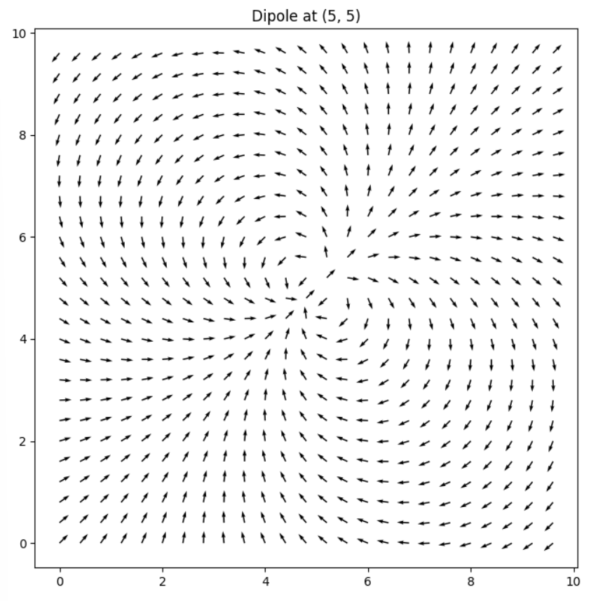
FIGURE 5: VECTOR FLOW FIELD CREATED BY A DIPOLE
When considering boundary conditions with the Laplace equation, it is possible to model flows around a corner, such as a flow along a winding river bed, or flow around an obstacle (see figure 6)
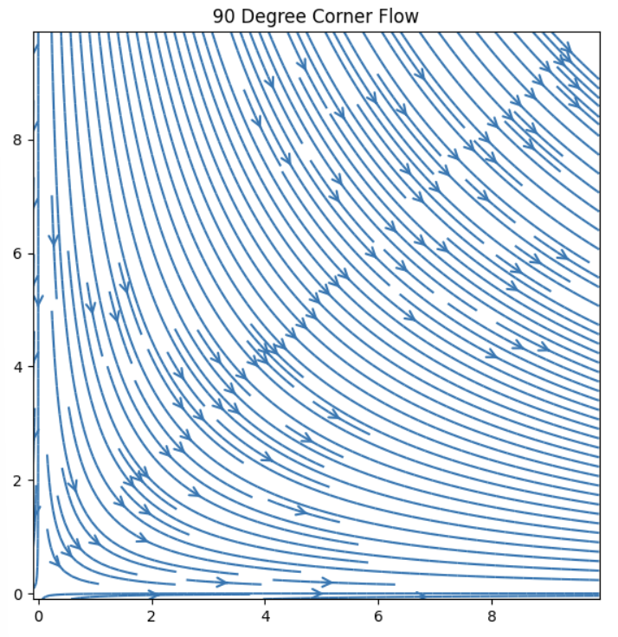
FIGURE 6: FLOW AROUND A 90-DEGREE CORNER
By combining vortices, sinks, sources, uniform flows, and dipoles, more complex vector fields can be created, such as a sinking vortex, a spring in a stream, or co-rotating vortices (see fig 7).
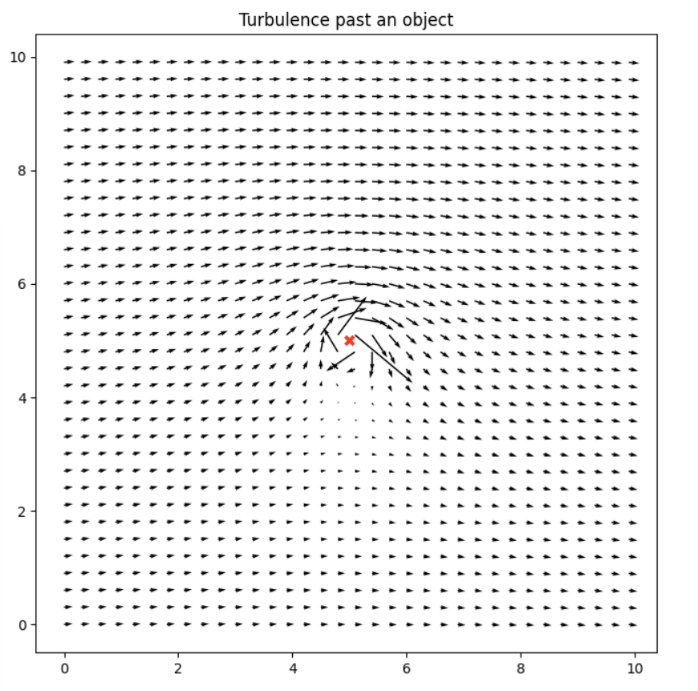
FIGURE 7: VORTEX SUPERIMPOSED WITH A UNIFORM FLOW
Free and fixed vortices can be superimposed to model a Rankine vortex, which simulates the vector flows in a tornado or in a hurricane, as it effectively replicates a pronounced eye that encapsulates a central region of tranquility.
2.3 Identifying Features in Vector Fields
By observing several complex vector fields from combinations of basis vector fields, a list of regions of interest has been compiled. Table 1 describes all interesting features that have been identified, and states which combinations can be used to create them.
Local extrema points such as a sink, source, or sinking vortex have been studied before, and navigating towards them has been demonstrated in both scalar and vector fields. The extrema point can also be the location of the source of a dipole, as the source has the strongest vector magnitude.
Equi-magnitude lines can be thought of as contour lines if a contour plot is made using the magnitude information of a vector field only (see fig 8). Finding an Equi magnitude line could be useful if the individual robots have limitations such as being unable to handle stronger environmental conditions in the vector field beyond some threshold.
The fastest flow in a stream has also been identified as a region of interest. In a magnitude only plot, this would be analogous to a crest. Finding the fastest flow is important, as it correlates to the highest flow rate in a stream for collecting debris or fish.
Stagnations points are areas where the velocity of the vector field is 0. A stagnation point in a vector field may exhibit saddle point behavior, in that it is stable in some direction, and unstable in other directions.

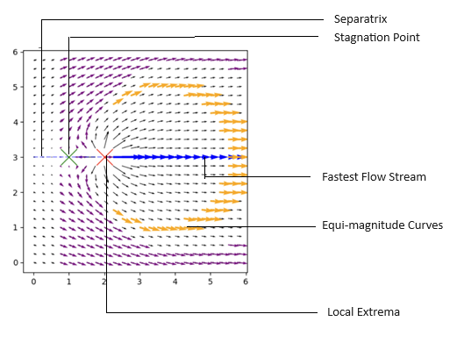
FIGURE 8: SPRING IN STREAM - SOURCE, STAGNATION POINT, FASTEST FLOW, CONSTANT FLOW

Another common feature in vector fields is a separatrix, a curve or trajectory that separates the phase into different dynamics. This can be seen in Figure 9. Following the Vectors below the separatrix point to a clockwise path, while the vectors above the separatrix point in a counterclockwise direction. Moving along a separatrix is analogous to traversing a ridge, as falling off the leads to differing paths of descent..
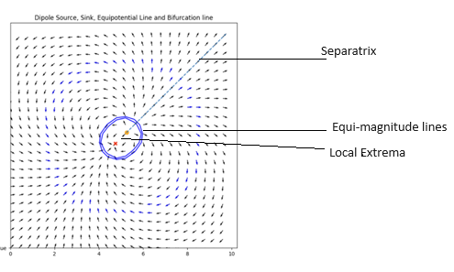
FIGURE 9: DIPOLE FEATURES INCLUDING EQUI MAGNITUDE LINES, EXTREMA POINT, AND A SEPARATRIX
Moreover, combining many flows and incorporating additional flow dynamics such as vorticals, features such as aperiodic orbits, stagnant trajectories, nodes, homoclinic trajectories, and chaotic attractors can be created. These features remain beyond the scope of this research. Furthermore, there may be scalar field regions of interest such as tunnels and overhangs that do not have vector field equivalents that are analogous.

Region of Interest | Fields Where Present
Extrema points | Sinks  Sources  Dipoles  Rankine Vortex  Fixed Vortex  Free Vortex  Sink + Vortex  Source + Vortex  Spring in Stream  Opposing Vortices  Corotating Vortices
Equi magnitude Contours | Sinks  Sources  Dipoles  Rankine Vortex  Fixed Vortex  Free Vortex  Sink + Vortex  Source + Vortex  Spring in Stream  Opposing Vortices  Corotating Vortices
Fastest Flow Stream | Corotating Vortices  Superimposed Linear Streams  Spring in Stream  Dipole  Vortex in Stream  Opposing Vortices  Rankine Vortex
Separatrix | Dipole  Vortex in stream  Opposing Vortices  Opposing Streams  Spring in Stream  Corotating Vortices
Stagnation Point | Spring in Stream  Opposing Vortices  Vortex in Stream  Opposing Streams  Superimposed Linear Streams
TABLE 1: REGIONS OF INTEREST IN VECTOR FIELDS

2.4 Control Primitives
Previous researchers established two classes of primitives for autonomous navigation of multirobot systems in vector fields [14]. These have been named as the ‘vector to scalar’ technique, and the ‘direction follower technique’. These will be described briefly, and 3 new techniques will be introduced in this section.
In the Vector to Scalar technique, only the magnitude information from the vector readings is used. Differences in sensor readings from the individual robots are used to calculate the normal angle to the plane, and then projected to provide the direction of steepest change. Equations 2 through 5 shows how the x and y coordinates and the magnitude of the vector readings (z) are used to determine the direction of travel. NB: The gradient becomes ill defined if the 3 robots formed a straight line.
$$\begin{aligned}{\vec{R}}_{12}=\left({x_{2}-x_{1} \atop \begin{aligned}y_{2}-y_{1} \\ z_{2}-z_{1}\end{aligned}}\right) \#\left(2\right)\end{aligned}$$
$$\begin{aligned}{\vec{R}}_{13}=\left({x_{3}-x_{1} \atop \begin{aligned}y_{3}-y_{1} \\ z_{3}-z_{1}\end{aligned}}\right) \#\left(3\right)\end{aligned}$$
$$\begin{aligned}\vec{N}={-\vec{R}}_{13}× {\vec{R}}_{13} \#\left(4\right)\end{aligned}$$
$$\begin{aligned}b_{grad}=ATAN2\left(N_{y} , N_{x}\right)+ \frac{π}{2} \#\left(5\right)\end{aligned}$$
The Direction Follower technique uses only the direction information from the vector readings. The direction of each vector reading is averaged by normalizing the magnitude of each vector then computing the vector sum. The direction of the resultant vector is then used to direct the multirobot system.
The Vector Sum technique is a newly proposed technique and is a modification to the direction follower technique, in that the vectors are not normalized before summing. This may lead to improvements when larger vectors are more important.
The Intersecting Vectors Technique is also being introduced as a technique that leverages the full vector information available. For each pair of robots, the intersection point of their vectors is calculated and then averaged. This guides the cluster towards, away, or around that feature based on distributed knowledge. This calculated point also provides an estimated position for the features of interest, which may be used in a higher controller layer to control acceleration or to determine the step size if discrete sampling is being used. This can be visualized in figure 10.
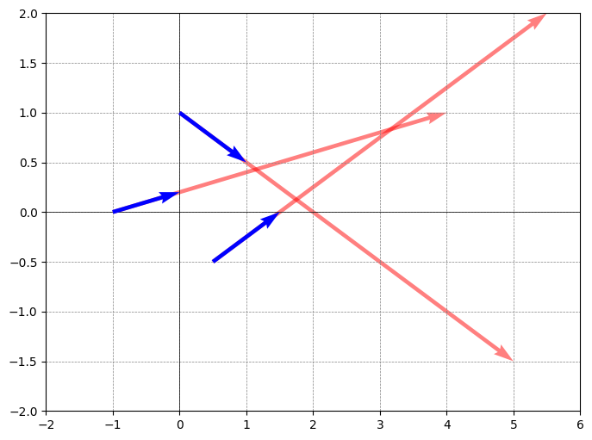
FIGURE 10: VISUALIZATION OF THE INTERSECTING VECTORS TECHNIQUE

The previous 4 techniques use averaging of all sensor readings. In contrast to averaging, the readings from the individual roots can be weighted differently based on some criteria. This is the basis for Nonlinear Weighting techniques. For example, it could weigh the robot readings such that only the minimum reading, the maximum reading, or the median reading is used. This selective weighting is the central premise to developing a primitive to traverse the separatrix line.
To traverse the separatrix line, the vector sum of the robot vector readings is calculated, and the resultant vector is compared to each robot via a cosine similarity score. The vector reading with the lowest cosine similarity score is then chosen as the direction to follow.
3. RESULTS AND DISCUSSION
3.1 Simulation Results
Previous investigation into vector field navigation demonstrated success in navigating towards and around local extrema. It demonstrated this behavior in vector fields of sinks, sources, fixed vortices, and in a sink superimposed with a vector.
The results obtained by [14] were replicated for these instances. Figure 11 demonstrates a three-robot cluster following the average vector direction to the source of a sinking vortex.

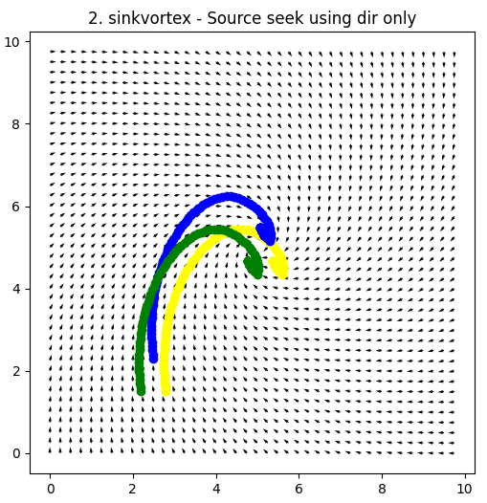
FIGURE 11: SEEKING EXTREMA IN SINKING VORTEX USING DIRECTION FOLLOW TECHNIQUE
By using the vector to scalar technique earlier proposed was also replicated, and it demonstrated to be apt in locating the local extrema points, particularly in sinks and sources or flows that super impose them, such as a sinking vortex. The ‘Vector to Scalar’ technique could also be used to orbit the extrema point by moving perpendicular to the direction of steepest ascent (see Figure 12).
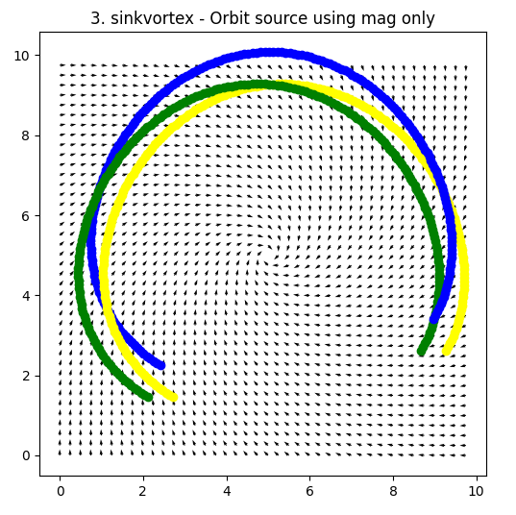
FIGURE 12: ORBITING SINKING VORTEX USING VECTOR TO SCALAR
Previous work has also demonstrated that these primitives can then be used sequentially to perform missions, such as the Fastest Flow Finder Technique. In that mission, they used only direction readings to reconfigure the cluster shape into a straight line, then use magnitude information only to navigate to the fastest flow in a stream moving along 1 axis only.
In contrast to this approach, this work demonstrates the ability to travel to the area of fastest flow without needing to change the cluster shape, nor without the need to use multiple primitives together in a mission. Figure 13 demonstrates the ability to reach the fastest flow of a Rankine Vortex using the vector to scalar technique.
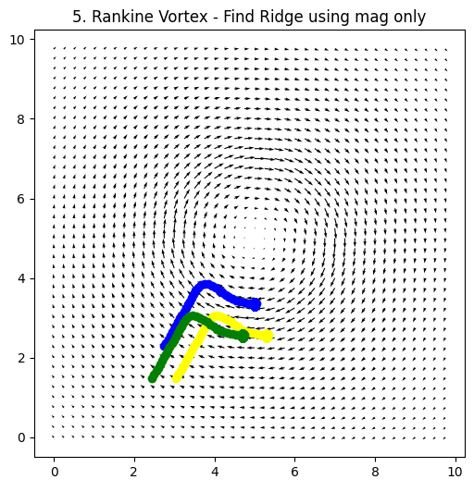
FIGURE 13: FASTEST FLOW OF RANKINE VORTEX
The vector to scalar technique was also used to find the stagnation point. By travelling perpendicular to the angle of steepest ascent, the robot cluster follows a curve that intersects with stagnation point. The results of this simulation can be seen in figure 14.
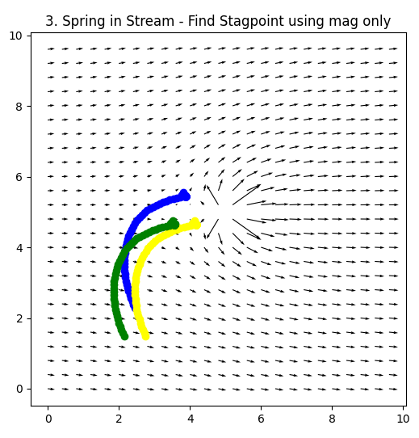
FIGURE 14: FIND STAGNATION POINT IN SPRING IN STREAM.
The nonlinear approach following the vector with the smallest cosine similarity score allowed the robot to traverse the separatrix line. This was demonstrated to work on separatrices associated with dipoles, springs in uniform flows, vortices in streams, and co-rotating vertices. Figure 15 demonstrates a three robot cluster moving against the direction of the vectors while tracking the Separatrix.

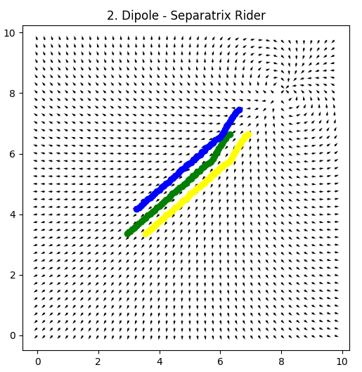
FIGURE 15: MANEUVER SEPARATRIX LINE OF A DIPOLE
The intersecting vector technique was only able to locate extrema in simple fields. Often, there were cases where the vectors were parallel and didn’t intersect, or the intersecting points might not all be in the forward direction. Perhaps this technique could have some threshold for closeness of intersecting points when deciding whether it should be used.

3.1 Future Work
The robustness of these algorithms to noise have not been analyzed. It would be interesting to test them not only with noisy environmental readings, being from the environment or from the sensor readings, but also with non-static environments. The controllers being used also maintain perfect formation. It would be interesting to check if the formation isn’t perfect. It could be worth analyzing the performance changes with different formations and different numbers of robots. This includes redundancy to noise rejection.
These techniques all involve using a centralized architecture. It would be worth extending these capabilities to non-centralized control techniques such as swarms.
Work has been done to create a physical test bed to test robot primitives using RGB cameras and a multicolored floor map. The study concluded that there was not enough resolution between the color channels to be an effective test bed. Testing these primitives on a physical test bed is crucial for evaluating their real-world performance, and work is being done to modify the test bed to enable physical experiments.
The list of regions of interest in table 1 is not exhaustive, and new features may be identified in the future. This work may be extended into 3-dimensional vector fields, which may also have additional features of interest.

4. CONCLUSION
This work successfully models complex vector fields using simpler ones and demonstrates the ability of newly derived primitives to seek newly identified regions of interest using 3 robot clusters. The vector fields were created by finding solutions to Laplace’s equation, and the regions of interest were created using superposition of different solutions. Three new techniques for were developed for three robot clusters, and each was used to maneuver to at least 1 feature of interest.

ACKNOWLEDGEMENTS
This research would not be possible without the funding from Santa Clara University’s Robotic Systems Laboratory. Special thanks to Dr. Kitts for his guidance, encouragement, and technical assistance.

REFERENCES
[1] Gradient-Based Cluster Space Navigation for Autonomous Surface Vessels Thomas Adamek, Member, IEEE, Christopher A. Kitts, Senior Member, IEEE, and Ignacio Mas, Member, IEEE
[2] C. A. Kitts and I. Mas, "Cluster Space Specification and Control of Mobile Multirobot Systems," in IEEE/ASME Transactions on Mechatronics, vol. 14, no. 2, pp. 207-218, April 2009, doi: 10.1109/TMECH.2009.2013943.
[3] I. Mas, S. Li, J. Acain, and C. A. Kitts, “Entrapment/escorting and patrolling missions in multi-robot cluster space control,” in Proc. IEEE/RSJ Int. Conf. Intell. Robots Syst., St. Louis, MO, USA, Oct. 2009, pp. 5855– 5861.
[4] M. Woolsey, C. A. Kitts and M. A. Neumann, "Gradient-based Adaptive Navigation of Multiple Diving Autonomous Surface Vehicles," OCEANS 2022, Hampton Roads, Hampton Roads, VA, USA, 2022, pp. 1-8, doi: 10.1109/OCEANS47191.2022.9977006.
[5] C. A. Kitts and M. Egerstedt, “Design, control, and applications of real world multirobot systems [from the Guest Editors],” IEEE Robot. Autom. Mag., vol. 15, no. 1, p. 8, Mar. 2008.
[6] Lee, Robert K., et al. "3-d adaptive navigation: Multirobot formation control for seeking and tracking of a moving source." 2020 IEEE Aerospace Conference. IEEE, 2020.
[7] S. T. Hart and C. A. Kitts, "Unifying Control Architecture for Reactive Particle Swarms," in IEEE/ASME Transactions on Mechatronics, vol. 28, no. 2, pp. 873-883, April 2023, doi: 10.1109/TMECH.2022.3211155.
[8] Hart, Shae T., Jake Kamenetsky, and Christopher A. Kitts. "Dynamic Elliptical Shaping Control for Swarm Robots." IEEE Access 11 (2023): 17454-17470.
[9] McDonald, Robert T., et al. "Navigation of scalar fronts with multirobot clusters in simulation and experiment." IEEE Systems Journal 14.3 (2020): 3755-3766.
[10] C. A. Kitts, R. T. McDonald, and M. A. Neumann, “Adaptive navigation control primitives for multirobot clusters: Extrema finding, contour following, ridge/trench following, and saddle point station keeping,” IEEE Access, vol. 6, pp. 17 625–17 642, 2018.
[11] Trakas, Panagiotis S., Andreas Tantoulas, and Charalampos P. Bechlioulis. "Formation Control of Nonlinear Multi-Agent Systems with Nested Input Saturation." Applied Sciences 14.1 (2023): 213.
[12] Matveev, Alexey, et al. "Non-Gradient Based Tracking of Environmental Field Isolines in a Changing Medium by Dubins-Vehicle Type Robots." IEEE Transactions on Automatic Control (2023).
[13] Cooper, Ryan, et al. "Initial Study of Multirobot Adaptive Navigation for Exploring Environmental Vector Fields." 2019 IEEE Aerospace Conference. IEEE, 2019.
[14] C. A. Kitts, R. T. McDonald, and M. A. Neumann, “Adaptive navigation control primitives for multirobot clusters: Extrema finding, contour following, ridge/trench following, and saddle point station keeping,” IEEE Access, vol. 6, pp. 17 625–17 642, 2018.
[15] I. Mas, S. Li, J. Acain, and C. A. Kitts, “Entrapment/escorting and patrolling missions in multi-robot cluster space control,” in Proc. IEEE/RSJ Int. Conf. Intell. Robots Syst., St. Louis, MO, USA, Oct. 2009, pp. 5855– 5861.
[16] Wang, J., Guo, Y., Fahad, M., and Bingham, B., 2019, “Dynamic Plume Tracking by Cooperative Robots,” IEEE/ASME Transactions on Mechatronics, early access.
[17] Liddy, Tommie, et al. "Obstacle avoidance using complex vector fields." Proc. of the 2008 Australasian Conference on Robotics and Automation, Canberra, Australia. 2008. – Single Robot with artificial vector field.
[18] Nelson, Derek R., et al. "Vector field path following for miniature air vehicles." IEEE Transactions on Robotics 23.3 (2007): 519-529.
[19] Hu, Bin-Bin, et al. "Spontaneous-Ordering Platoon Control for Multirobot Path Navigation Using Guiding Vector Fields." IEEE Transactions on Robotics (2023).
[20] Braquet, Martin, and Efstathios Bakolas. "Vector field-based collision avoidance for moving obstacles with time-varying elliptical shape." IFAC-PapersOnLine 55.37 (2022): 587-592.
[21] Yao, Weijia, et al. "Singularity-free guiding vector field for robot navigation." IEEE Transactions on Robotics 37.4 (2021): 1206-1221.
[22] Rajabhandharaks, Danop, et al. "Indoor Testbed for Vector Field Multirobot Adaptive Navigation: Feasibility Study." International Design Engineering Technical Conferences and Computers and Information in Engineering Conference. Vol. 59292. American Society of Mechanical Engineers, 2019.
[23] Matveev, Alexey, et al. "Gradient-free tracking of unsteady environmental level sets in dynamic environments by a nonholonomic robot." IFAC-PapersOnLine 53.2 (2020): 9256-9261.
[24] Garg, Kunal, and Dimitra Panagou. "Finite-time estimation and control for multi-aircraft systems under wind and dynamic obstacles." Journal of Guidance, Control, and Dynamics 42.7 (2019): 1489-1505..
[25] Thangavelautham, Jekan, and Yinan Xu. "Co-Evolution of Multi-Robot Controllers and Task Cues for Off-World Open Pit Mining." arXiv preprint arXiv:2009.09149 (2020).
[26] Kalita, Himangshu, et al. "Guidance, navigation and control of multirobot systems in cooperative cliff climbing." arXiv preprint arXiv:1701.07553 (2017)
[27] R. K. Lee, C. A. Kitts, M. A. Neumann and R. T. Mcdonald, "Multiple UAV Adaptive Navigation for Three-Dimensional Scalar Fields," in IEEE Access, vol. 9, pp. 122626-122654, 2021, doi: 10.1109/ACCESS.2021.3107854.

